Name: S Nithin
USN: 1RVU23CSE388
Date: 13/01/2026
Sub: Foundations of Generative AI

LAB 1: First prompts using ChatGPT/Gemini/Perplexity/Claude, Prompt example of launch Email for a Workshop, Using DALL-E via Image creator, creating a video using Fliki.ai and Kalaido.ai
Launch email prompt:
Write a launch Email for a workshop
Title of the workshop: Basic Life Support (BLS)
Detail to include:
What and why BLS is?
Why you should attend the event
What you'll learn and more
It is being held at RV University. It's a one day workshop. Timing : 0900hrs to 1500hrs. Lunch is provided.

DELIVERABLE:
Subject: 🚑 Basic Life Support (BLS) Workshop – One Day Training
Dear Participant,
We are pleased to announce a one-day Basic Life Support (BLS) Workshop at RV University.
What is BLS?
Basic Life Support (BLS) is the immediate care given to a person experiencing a life-threatening emergency such as cardiac arrest, choking, or breathing failure until professional help arrives.
Why BLS?
Quick and correct response during the first few minutes of an emergency can save lives. BLS training prepares you to act calmly and confidently in such situations.
Workshop Details:
📍 Venue: RV University
📅 Duration: One Day
⏰ Time: 0900 hrs – 1500 hrs
🍽 Lunch: Provided
What you’ll learn:
- CPR basics
- Managing choking and breathing emergencies
- Introduction to AED usage
- Practical emergency response skills
Be prepared. Be confident. Be a lifesaver.
Warm regards,
S Nithin

POSTER PROMPT:
A minimal, modern poster design for a Basic Life Support (BLS) workshop.
Soft, realistic background image of a person being helped during a medical emergency, slightly blurred to keep focus on the text.
Clean layout with ample white space and a professional medical feel.
Subtle lighting, calm and reassuring atmosphere.

Text elements clearly displayed in simple, bold typography:
• Venue: RV University
• Time: 0900 hrs – 1500 hrs

Large, bold call-to-action text at the bottom:
REGISTER NOW

Color palette: white, light grey, and red accents.
Flat design elements, minimal clutter, high readability.
Poster-ready, realistic, suitable for university notice boards and digital promotion.

DELIVERABLE:
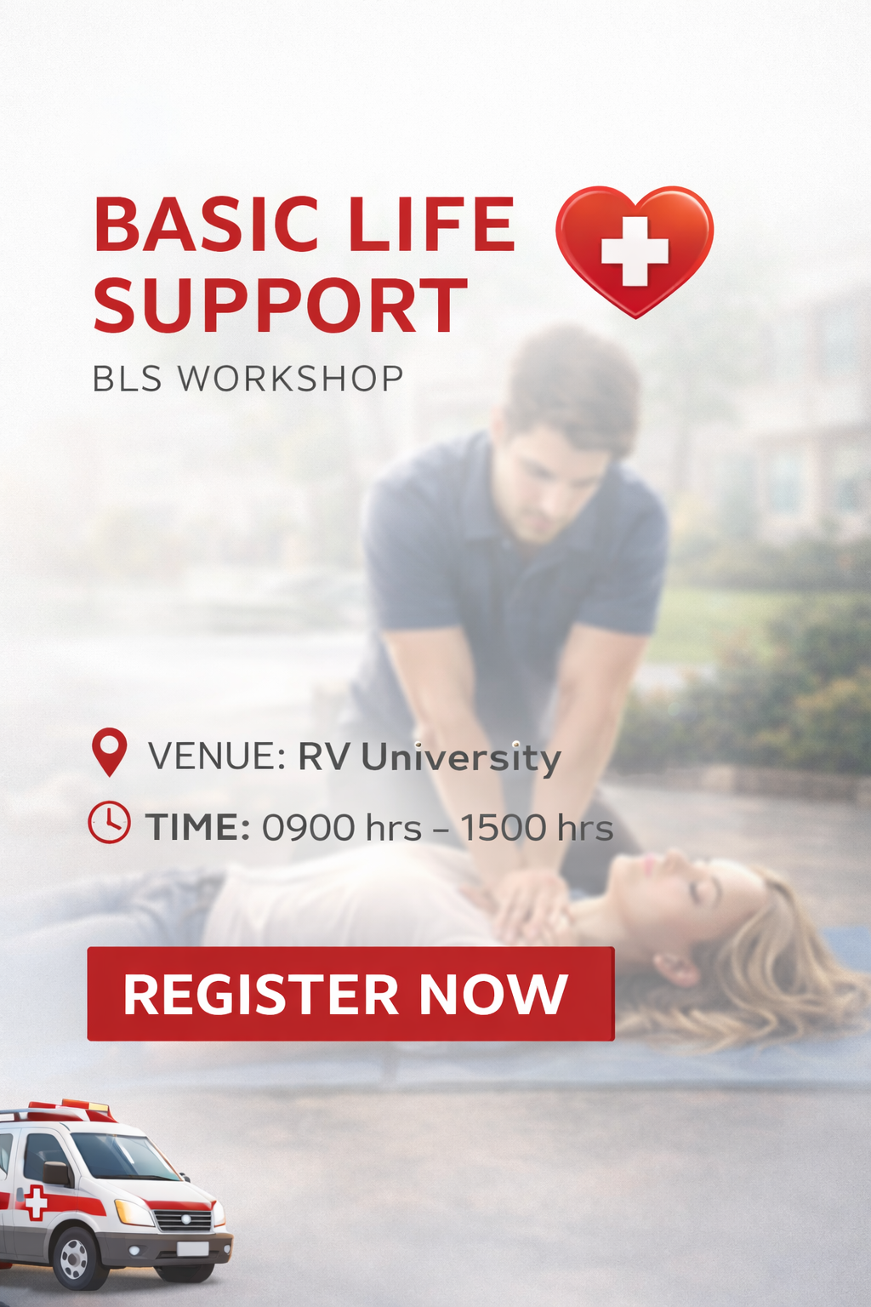
VIDEO AND AUDIO PROMPT:
Short, impactful medical visuals showing emergency response situations.
Close-up shots of CPR chest compressions, rescue breathing, and AED usage.
Trained individuals calmly assisting patients during cardiac arrest and choking emergencies.
Clean educational visuals with smooth transitions.
On-screen text highlights: “Basic Life Support (BLS)”, “CPR”, “AED”, “Early Action Saves Lives”.

DELIVERABLE:
